Module 03 – Production Modeling

Exploratory Data Analysis

*In this section, you should perform some data analysis on the data provided to you. Please format your findings in a visually pleasing way and please be sure to include these cuts:*

* *Make a table of average demand, production capacity, and costs for each quarter, are there differences between quarters?*
* *Since we have temporal data (i.e. year and quarter), see if you can make a yearly and/or quarterly chart showing these metrics over time.*

**

**

Model Formulation

*Write the formulation of the model into here prior to implementing it in your Excel model. Be explicit with the definition of the decision variables, objective function, and constraints*

50.40\*P1 + 49.96\*P2 + 46.73\*P3+47.44\*P4 + 1.29\*(B1+B2)/2+ 1.29\*(B2+B3)/2 + 1.29\*(B3+B4)/2

Production level for Q1: P1<=507

Production level for Q2: P2<=475

Production level for Q3: P3<=519

Production level for Q4: P4<=499

Ending Inventory for Q1: B1+P1-507 >=31

Ending Inventory for Q2: B2+P2-475>=41

Ending Inventory for Q3: B3+P3-519>=36

Ending Inventory for Q4: B4+P4-499>=65

P=units produced

B=beginning inventory

Model Optimized for Cost Reduction

*Implement your formulation into Excel and be sure to make it neat. This section should include:*

* *A screenshot of your optimized final model (formatted nicely, of course)*
* *A text explanation of what your model is recommending*

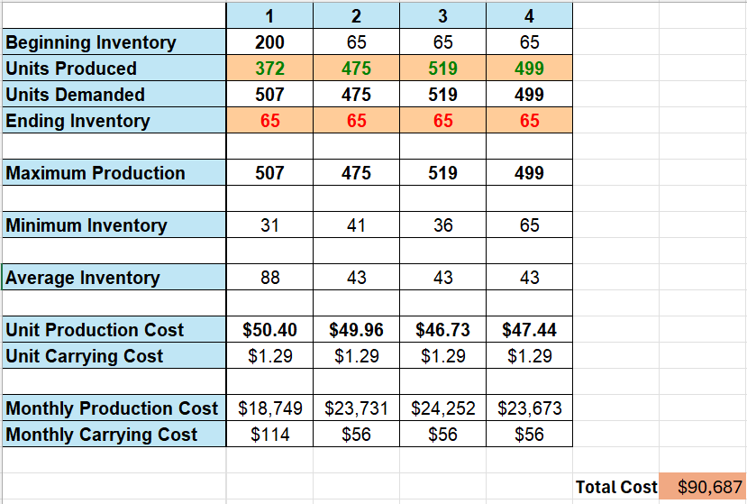

My model is recommending that the units produced should be 372 in Q1, 475 in Q2, 519 in Q3, and 499 in Q4 to get the lowest costs for production based on average demand, max production, and any associated costs such as production and carrying costs. As a result the total cost is $90,687.

Model with Stipulation

*Please copy the tab of your original model before continuing with the next part to avoid messing up your original solution. If we remove the production capacity constraint from the model & we removed the carrying cost, what do you think will happen? Try it out and see if it matches your expectation. Try to explain what is happening and talk a bit about fallbacks of models.*

I expect the units produced will not be evenly dispersed and will mostly fall in q3 as there are no carrying costs and that has the lowest production costs.

That is essentially what happened as the model is just looking to get the lowest costs and the only constraint is ending inventory has to be greater than or equal to minimum inventory. The model is favoring quarter 3 by a lot because of that and is producing everything it can in that quarter. This shows the fallbacks of models especially if you do not have enough constraints and there is not enough info given then you will receive a skewed answer. This shows the weakness that models can have even though they are still a very useful tool.